
ABC’s of Kindergarten
Mrs. Cox’s Kindergarten Handbook
Important Contact Information
Mrs. Cox- room 118
E-mail: angela.cox@weschools.org
Office: 440-944-3130
Attendance Line: 440-283-2179


After-School Transportation- If there are any changes to your after-school transportation, you must send a written note to school. Please do not rely on your child to give me the message. If I do not receive a written note, then I must send your child home by his/her usual mode of transportation.
Attendance - Your child's regular and prompt attendance is important to his/her success in school. Make sure your child attends every day except in cases of illness or emergency. If your child is absent, please call the school office.
Art- We will be doing fun art projects! Our class will use many different materials to create beautiful and unique works of art.
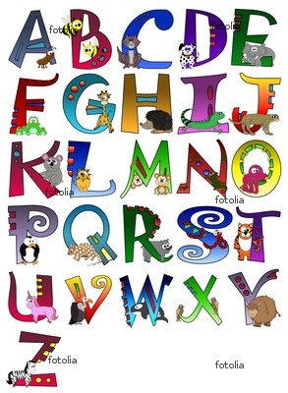
Birthdays- If you would like to have your child bring in a SIMPLE treat for the class on his/her birthday; please send a note a few days in advance. We will celebrate summer birthdays towards the end of the school year. I will let you know which month that will be. In order to avoid hurt feelings, party invitations may only be passed out at school if everyone in the class is getting an invitation.
Communication- Communication between parent and teacher is vital to a successful school year. If you have any questions, concerns, suggestions, or comments, feel free to contact me at school or you can send a note with your child. I can also be reached through email at Angela.cox@weschools.org.

Daily 5 - This year your child will be involved in a program called Daily 5 for both math and literacy. A letter will be sent home to explain the program.
Our Day - Our school day begins at 8:40AM and ends at 2:40PM Monday through Friday.
Dropping Off & Picking Up- Drop-off will be located at the main doors by number 118. Students line up at the main door at approximately 8:30 AM. Make sure to follow the drop off pattern.
Emergencies- Please make sure you complete and return the PINK EMERGENCY form ASAP. I must have one for every student. Also, if you get a new phone number or move to a new home, please update this information with the office so that we can get in touch with you right away in case of an emergency.
Fundations- We will be using a combination of the Fundations Program and Phonics in Motion Program. Your child will begin blending and segmenting sounds shortly after we begin our school year.
Gym- Your child will have two 30 minute gym classes per week with Ms. Seufer. Please remember to dress your child appropriately for gym! Tennis shoes must be worn!
Homework- your child should be reading for about 15 minutes per night and practicing reading the Kindergarten “No-Excuse” Words for about 5 minutes per night. A math worksheet will be sent home a few times a week. There will be a few family homework projects too!
Illness- The question of when to keep your child home from school is often a difficult one. However, it is important to keep your child home if he/she is ill. This helps to make them more comfortable and prevents others from becoming ill.
Ice Cream - Ice cream can be purchased at lunch for $0.50. If your child is purchasing ice cream, please remember to send the money in an envelope clearly labeled with their name and the purpose of the money. Please leave ice cream money in your child’s lunchbox if they are packing.

Journals- We spend a lot of time writing in our journals. Eventually this will be a daily activity in our classroom.

Kindness- Students in our classroom are encouraged and expected to treat all members of our class as well as others with kindness and respect. Bothering others, bullying and interrupting learning will not be permitted.

Library- Our library day is .
The children will go to the library once a week for 30 minutes. They will have a chance to select a book to check out for the week. Library books should be kept in our backpacks so that they can be easily found on library day.

Lunch- Lunch time is from 11:00-12:00. The children may buy lunch at school or bring one from home. Menus will be sent home every month. Weekly or monthly lunch tickets may be purchased through the office. Any money sent in must be in an envelope that is clearly labeled with your child’s name and the purpose of the money. Lunch is $2.85 a day and milk is $0.50.
**Kindergarteners are STRONGLY encouraged to pack their lunch for the first 2 weeks of school- just until they get used to the lunchroom. **

Math- Students will participate in routines within the framework of a Math meeting, practicing skills such as using a calendar, graphing weather, adding number of the day, predicting pattern, etc. In addition, students will be instructed in a whole class math activity and then spend time exploring these concepts with math manipulatives or games.
Math Meeting- We will have “Math Meeting” every day. This is the time where we discuss the calendar, the days of the week, the months of the year, the seasons, the weather/temperature, count money, tell time, identify patterns, skip count, etc.

Money- If you send in money, please place it in an envelope that is clearly labeled with your child’s name and the purpose of the money. This envelope should then be placed in your child’s STAR Book.

Music- Our class is scheduled to have music twice a week for 30 minutes with Ms. Stancombe.

Nurse- We are very fortunate to have a wonderful nurse at our school and a fantastic nurse’s aide. Both will tend to minor scratches and scrapes as well as sudden illnesses. For more serious injuries either one will contact you. Please be sure to send in any change of contact numbers in case they need to get in touch with you.

No-Excuse Words - Kindergarten “no-excuse” words are a part of our Language Arts curriculum. No-excuse words are basic sight words that do not follow the rules of the English Language. .
Open House- This is a time for your child to bring their family to school to share all of the things we’ve been learning. More information to come.
Outdoor Recess- The children will be going out for recess every day unless it is raining or extremely cold. Please keep this in mind when helping your child select clothes for the day.
Parent-Teacher Conferences- We will have scheduled Parent-Teacher Conferences in November at the end of the first grading period. Progress reports will be going home with all kindergarten students during the first months of school.
Parties- There are 3 parties throughout the school year: Halloween, Holiday and Valentine’s Day. More information will be sent home regarding parties.
Popcorn- Popcorn can be purchased in advanced for the school year or once a month. More info to come.
PTA- I encourage all parents to join our school's Parent-Teacher Association.
Quick Goodbyes- Quick goodbyes (at home or in the car) will leave drier eyes.

Reading- Wonder is our new Reading Program used in Willoughby-Eastlake Schools. Reading instruction will be both whole-group through shared reading activities and read-alouds and small –group through guided reading groups.
Report Cards- Students will receive report cards four times during the school year after every 9 weeks.
Scholastic Book Orders- Scholastic Book Order forms will be sent home with your child once a month. This is a chance for you to buy books for your child at low prices. Plus our class earns free books and other items for our classroom for every parent purchase! If you would like to order, fill out the form and a check made out to Scholastic Book Club, and return it to school in an envelope. You can also order books and pay for them online as well.
School Supplies- Please send in your child’s school supplies ASAP. Also, some items may need to be replaced or replenished throughout the school year.
Snacks- Please send in a healthy one-handed snack for your child each day. Some ideas are cheese, fruit, fruit snacks, crackers, etc.
STAR Chart- Each day, I will send home our STAR CHART in your child’s folder. This chart must be signed and returned each day. The star chart will be used to communicate how your child’s day at school went and other important information as it comes up. If your child receives a green star on the chart, you will know that they had a great day! If your child had a difficult day, the comment section will keep you informed of any incidents. Please feel free to write a note on the star chart if you have any questions or concerns.

STAR BOOK - The STAR BOOK will hold everything the students and parents need to keep updated on classroom and school events! The STAR BOOKs will come home daily with class work, newsletters or any distributions from school. Please empty the contents of each folder in the STAR Folder each night. Return the STAR Folder each day with any correspondence from home.
Star Student- Each student will have the opportunity to be “Star Student” for a week. When they are “Star Student,” they will share some special facts about themselves and bring a favorite toy or book to show the class. I will let you know in advance when it is your child’s turn!
Toys- Bringing toys to school are discouraged because they distract the children from learning. However, a toy may me brought when your child is Star Student. When your child brings in a toy for “Star Student” item, please make sure it is clearly labeled with their name.
Units of Study- Each month we study different science and social studies units. We make special projects and learn facts based on our unit. The kindergarten social studies curriculum focuses on the students and how they relate to others in their families, classroom, school, and community. Science units include Our 5 Senses, Plants, Animals, Seasons, and the Life Cycle of the Butterfly.
Volunteers- During the school year, we will have a variety of special classroom activities that require parent volunteers. More information will be sent home later.
Writing- Daily writing practice will consist of letter formations, writing words, sentences and stories. We will also focus on using proper spacing and punctuation. If possible, please provide your child with writing tools, such as pencils, crayons, markers and paper at home.

Wesbite- Check out our class website for weekly updates and important dates
“X-tra” Special Experiences- Kindergarten is such an exciting time! We are learning about the magic of books, letters, numbers, poetry, songs, science, social studies, art, music, gym class, computers and oh, yes....school rules! Enjoy this year and let your kindergartner know how important school is to you.
Yearbook You will be able to purchase a yearbook at the end of the school year.
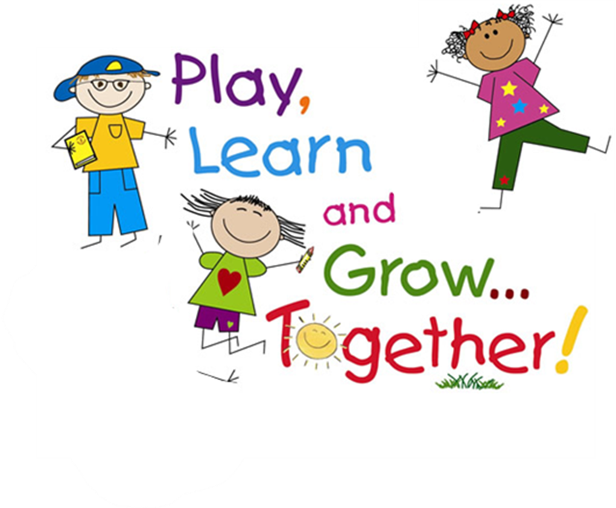
ZZZ's It is so important to make sure your child is getting a good night's sleep. Establish a bedtime routine that allows your child to get 8-10 hours of sleep each night.

